**Hamilton Beach Blender**

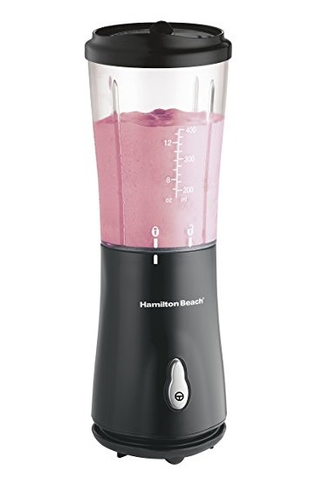

**Key Features  
  
  Brand Warranty  
 4 accessories to perform 18 functions  
 1.2L family sized food processor bowl  
 2 speed with pulse setting  
 Stainless steel chopping blades  
 Slicing and shredding disc included  
 Price per Unit: $50/-**

**CORPORATE OFFICE**

    1300 E. Control Tower Rd.  
    Suite 216 Block L3  
    Englewood CO 80112  
 Phone: 720.974.7878  
    Toll Free: 1.877.929.7878  
    Email: [info@choicescreening.com](mailto:info@choicescreening.com)